Roel R. Lopez, Ph.D.

Curriculum Vita – Summary

EDUCATION:
Doctor of Philosophy, Texas A&M University, 2001.
Master of Science, Texas A&M University, 1996.
Bachelor of Science in Forestry, Stephen F. Austin State University, 1993.
Certified Wildlife Biologist, The Wildlife Society, 2003-present.
EXPERIENCE:
Department Head, Rangeland, Wildlife and Fisheries Management, 2021-present.
Director, Texas A&M Natural Resources Institute (NRI), 2012-present.
Director, Texas Water Resources Institute (TWRI), 2012-2015.
Associate Director, Texas A&M Institute of Renewable Natural Resources, 2009-2012.
Professor, Texas A&M University, Department of Wildlife and Fisheries Sciences, 2011-present.
Special Assistant to ADUSD-I&E, Office of Secretary of Defense, 2007-2009.
Associate Professor, Texas A&M University, 2006-2011.
Assistant Professor, Texas A&M University, 2001-2006.
Wildlife Biologist, U.S. Fish and Wildlife Service, 2000-2001.
Research Ecologist, URS Greiner Corporation/Dames and Moore, 1999-2001.
Instructor, Florida Keys Community College, 1998-2001.
Teaching Assistant, Texas A&M University, 1995-1997.
Research Assistant, Texas A&M University, 1993-1994.
Wildlife Biologist, U.S. Forest Service, Sabine National Forest, 1990-1993.
RESEARCH:
Grants (1994-present) $42,630,810 – 209 total.
Graduate Students (Chair/Co-chair) – 113 graduate students.
Total 171: Peer-Reviewed Journal Articles (148); Book Chapters (22); Book (1)
Awards – 53 total including:
- TAMUS Regents Fellow Service Award, 2022
- RWFM Award in Undergraduate Teaching, 2021
- TWA Sam Beasom Conservation Leader Award, 2019
- USFWS Southeast Regional Recovery Champion, Team Award, 2016.
- Texas Chapter of TWS Outstanding Technical Article, 2016.
- TAMU Vice Chancellor’s Award in Excellence – Research Team, 2014.
- Texas Chapter of TWS Outstanding Educator Award, 2013.
- TWS Diversity Award, 2008.
- TWS Outstanding Publication Award, 2008, 2005, 2003.
- TAMU Vice Chancellor’s Award in Excellence – Diversity Award, 2007.
- USDA CSREES New Teacher Award, 2006.
- Montague Center for Teaching Excellence Scholar, 2003.
TEACHING:
Military Land Management and Program Director for Military Land Sustainability graduate certificate (WFSC 641, WFSC 642, WFSC 643, WFSC 644, WFSC 681, WFSC 689)
Wildlife and Habitat Management Courses (WFSC 300, WFSC 406, WFSC 407, WFSC 408 [lab], WFSC 636)
Wildlife Ecology and Behavior Courses (WFSC 215, WFSC 403, WFSC 422)

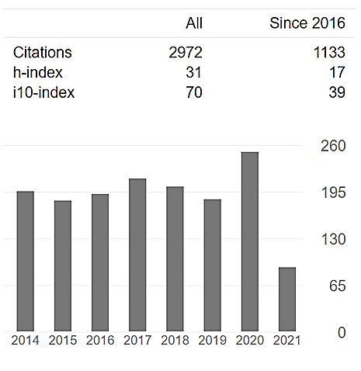
RESEARCH HIGHLIGHTS:
Grants (1994-present) $42,630,810 – 209 total.
Annual 10 year Average | $3,543,729
Total 10-year | $38,981,017

Graduate Students (Chair/Co-chair) – 113 grad students.
Completed | 85
Current | 28

Completed (Last 10 Years) | 50
Veteran Students | 14
Veteran Students (%) | 28%

Chair/Co-chair – 113 graduate students (28 current, 85 graduated [15 Ph.D., 70 MS/MSW])
Committee Member – 55 graduate students
Total 171: Peer-Reviewed Journal Articles (148); Book Chapters (22); Book (1)
Average of 7 publications annually last 10 years

SELECT PUBLICATIONS:
*Denotes graduate student
R.R. Lopez, C. Brown, and A. Lopez. 2021. Participation Equals Conservation: Why Diversity Matters in Sustaining our Natural Resources. The Wildlife Professional. May/June 2021:38-42. Bethesda, MD. Invited Feature.
*Khan, J.M., Dudding J., Hart M., Robertson C.R., Lopez R.R., Randklev C.R. 2020. Linking flow and upper thermal limits of freshwater mussels to inform environmental flow benchmarks. Freshwater Biology. 2020;00:1–16. https://doi.org/10.1111/fwb.13598
Lopez, R.R., N.J. Silvy, M.J. Peterson, D. Brooks, E. Bauer, and F. Gonzalez. 2018. Curassows, Guans, and Chachalacas. Wildlife Ecology and Management in Mexico. R. Valdez and J. A. Ortega-S., editors. Texas A&M Press, College Station, TX. Spanish version.
Lopez, R.R., I. Parker, and M.L. Morrison. 2017. Applied Wildlife Habitat Management. Texas A&M AgriLife Research and Extension Service Series. Texas A&M Press, College Station, TX. Pages 240.
*Schmidt, P.M., R.R. Lopez, and B.A. Collier. 2007. Survival, Fecundity, and Movements of Free-Roaming Cats. Journal of Wildlife Management 71:915-919.
Lopez, R.R., A. Lopez, R.N. Wilkins, C. Torres, R. Valdez, J. G. Teer, and G. Bowser. 2005. Changing Hispanic Demographics: Challenges in Natural Resource Management. Wildlife Society Bulletin. 33:553-564. TWS Outstanding Publication Award recipient, 2008.
Lopez, R.R., N.J. Silvy, R.F. Labisky, and P.A. Frank. 2003. Hurricane Impacts on Key Deer in the Florida Keys. Journal of Wildlife Management. 67:280-288. Texas Chapter TWS Outstanding Publication Award recipient, 2005.
*Peterson, M.N., T.R. Peterson, M.J. Peterson, R.R. Lopez, and N.J. Silvy. 2002. Cultural Conflict and the Endangered Florida Key Deer. Journal of Wildlife Management. 66:947-968. Texas Chapter TWS Outstanding Publication Award recipient, 2003.
Lopez, R.R. 2001. Rigor in Wildlife Education: Where the Rubber Hits the Road. Wildlife Society Bulletin. 29:1038-1042 (Special Coverage).

